SPRINT -3

Date | 07 November 2022
TEAM ID | PNT2022TMID04063
Project Name | IoT Based smart crop Protection system for agriculture
Maximum mark | 20 marks

STEP1: Node Red flow to get simulated data

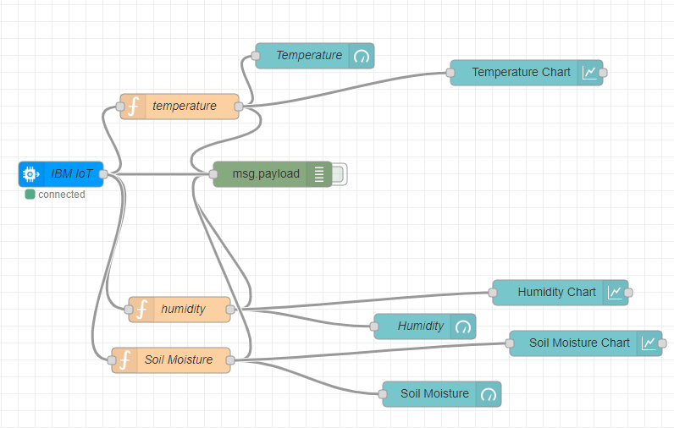

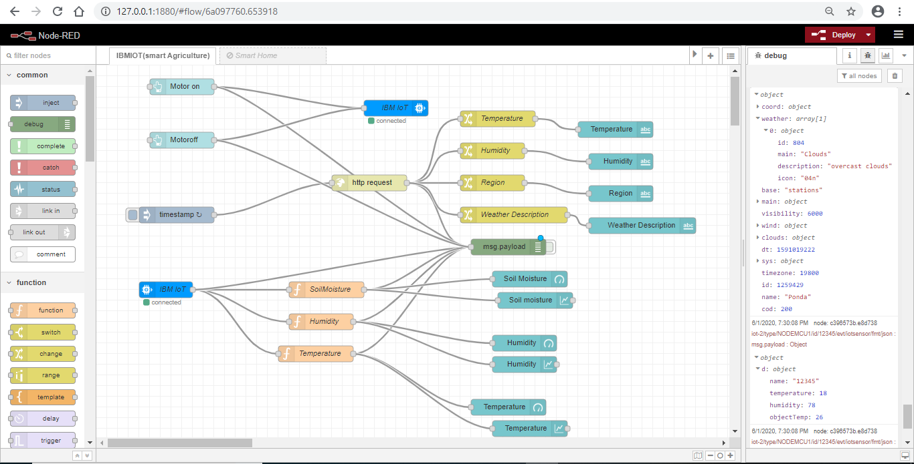

STEP 2 : Stimulated Outputs

